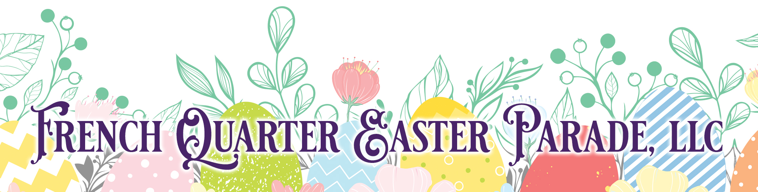

The Auction

The French Quarter Easter Parade requests your consideration in contributing an auction item of your products or services for this year's 39th Anniversary festivities. The parade and events surrounding it have become a tradition for many New Orleanians and their families.
We are keeping all of our long-standing traditions, including the Silent Auction which will help the Easter Parade raise monies to support music education in New Orleans. We would like you to join us in contributing to this important cause and we hope you will participate by donating an auction item for this special event on Easter Sunday, March 31st, 2024, beginning at 11:00 AM. In return for your participation, you will receive acknowledgment for your company in the event program and signage.
The celebration starts at the Omni Royal Orleans Grand Ballroom at 11:00 AM with a Hat Contest and music. We will then hop on the floats and ride through the French Quarter. Following the parade, the fun continues with a Champagne Brunch and dancing to the musical sounds of David Cook and the Yat Pack.
We hope that you will join us in making this year's parade bigger and better than ever. Your auction item is sure to make it and "Egg-straordinary" Easter!
Tim Jones, Auction/Prize Coordinator

For Organizational Purposes: Please print and fill in by March 27, 2024.
Name Company Name
Address
Phone/Fax Email
Auction Items:1. 2.
3. 4.
Dollar Value of Items:1. 2.
3. 4.

For additional information, please contact Tim Jones at 504.450.6071

